**MULTIFACETED DIGIT RECOGNITION USING LONG SHORT TERM MEMORY AND CONVOLUTIONAL NEURAL NETWORKS**

**A PROJECT REPORT**

*Submitted by*

**HARIBHARATH MAHALINGAM 312316104054**

In the partial fulfilment for the award of the degree

Of

**BACHELOR OF ENGINEERING**

In

**COMPUTER SCIENCE AND ENGINEERING**



**St. JOSEPH’S COLLEGE OF ENGINEERING, CHENNAI**

**ANNA UNIVERSITY :: CHENNAI 600025**

**MAY 2020**

**ANNA UNIVERSITY : CHENNAI 600025**

**BONAFIDE CERTIFICATE**

This is to certify that the project title ‘**MULTIFACETED DIGIT RECOGNITION USING LONG SHORT TERM MEMORY AND CONVOLUTIONAL NEURAL NETWORKS’** is the bonafide work of **HARIBHARATH MAHALINGAM (312316104054)** who carried out the project under my supervision.

**Dr. A. CHANDRASEKAR M.E, PH.D., Mr. P. VARUN**

**HEAD OF THE DEPARTMENT SUPERVISOR**

**PROFESSOR ASSISTANT PROFESSOR**

Department of Computer Science Department of Computer Science

And Engineering and Engineering

St. Joseph’s College of Engineering St. Joseph’s College of Engineering

OMR, Chennai-600 119 OMR, Chennai-600 119

Submitted for the University Viva Voice held on __________

INTERNAL EXAMINER EXTERNAL EXAMINER

**ACKNOWLEDGMENT**

The contentment and elation that accompany the successful completion of any work would be incomplete without mentioning the people who made it possible.

Words are inadequate in offering my sincere thanks and performed gratitude to **Dr. B. Babu Manoharan, M.A., M.B.A., Ph.D.**, Chairman, St. Joseph’s Group of Institutions for providing an opportunity to study in his esteemed institution.

I also express my sincere thanks and gratitude to beloved **Ms. B. Jessie Priya, M.Com**. And **Mr. B. Shashi Sekar**, **M.Sc.,** Directors, St. Joseph’s College of Engineering for extended their helping hands at all times during the course.

I am extremely happy to express my sincere thanks gratitude to **Dr. Vaddi Sesahgiri Rao M.E., M.B.A., Ph.D.**, Principal, St. Joseph’s College of Engineering for his encouragement throughout the course.

I also express my sincere thanks and most heartfelt sense of gratitude to **Dr. A. Chandrasekar, M.E., Ph.D.**, Head of the Department of Computer Science and Engineering, for his dedication, commendable support and encouragement for the completion of project work with perfection.

It is with deep sense of gratitude that I acknowledge my indebtedness to my supervisor **Mr. P. Varun, M.Tech. (Ph.D.)**, Assistant Professor, Department of Computer Science and Engineering for his valuable suggestions and for his technical support rendered during the project days.

Last but not the least, I thank my family members, and friends who have been the greatest source of support to me.

**ABSTRACT**

Communication is one of the key elements of interaction. In order to understand the language used by humans, machines use different techniques like converting speech to machine readable form called speech recognition and recognising handwritten or text data. This project is about developing a multifaceted digit recognition application that integrates three individual applications to recognise spoken digits and handwritten digits implementing two different neural networks correspondingly. Spoken digit recognition is done with the help of the Long Short-Term Memory (LSTM) network along with Mel-frequency Cepstral coefficients (MFFC) algorithm to extract features and classify the signals. Handwritten digit recognition is done with the help of Conventional Neural networks. A major advantage of using the LSTM is that it overcomes the vanishing gradient problem in the CNN and this proposed technique can be used in applications like entry of numerical data for blind people, telephone directory services, online ticketing and bank services. LSTM provides an accuracy of 100% in recognising the digits 0-9 while CNN provides lesser varying accuracies. The third application uses the same CNN network to recognise handwritten digits through a webcam. Thus, this project presents an application that integrates recognition of spoken and handwritten digits with the help of LSTM and CNN neural networks respectively.

**TABLE OF CONTENTS**

**CHAPTER TITLE PAGE NO:**

**NO:**

**ABSTRACT** iv

**LIST OF FIGURES** vii

**LIST OF ABBREVIATIONS**  viii

**1 INTRODUCTION** 1

* 1. GENERAL 1
  2. NEURAL NETWORKS 1

1.2.1 Types of Neural Networks 4

1.3 LONG SHORT TERM MEMORY NETWORK 5

1.4 CONVOLUTIONAL NEURAL NETWORK 9

1.5 OBJECTIVE 16

1.6 EXISTING SYSTEM 16

1.7 PROPOSED SYSTEM 17

1.7.1 Advantages 17

1. **LITERATURE SURVEY** 18

**3 SYSTEM REQUIREMENTS** 21

3.1 HARDWARE REQUIREMENTS 21

3.2 SOFTWARE REQUIREMENTS 21

* 1. CODING LANGUAGE USED 25

**4 SYSTEM DESIGN** 29

4.1 ARCHITECTURE DIAGRAM FOR 29

SPOKEN DIGIT RECOGNITION

4.1.1 Flow Diagram 30

4.2 ARCHITECTURE DIAGRAM FOR 32

HANDWRITTEN DIGIT RECOGNITION

* + 1. Flow Diagram 33

**5 SYSTEM IMPLEMENTATION** 35

5.1 MODULAR DESCRIPTION 35

5.2 SPOKEN DIGIT RECOGNITION 36

5.2.1 Dataset collection 36

5.2.2 Feature extraction 36

5.2.3 Building LSTM network 36

5.2.4 Testing and classification 38

5.3 HANDWRITTEN DIGIT RECOGNITION 39

5.3.1 Dataset collection 39

5.3.2 Pre-processing image 39

5.3.3 Building CNN network 40

5.3.4 Testing and classification 41

* + 1. Testing through webcam 41

**6 CONCLUSION AND FUTURE ENHANCEMENT** 42

6.1 CONCLUSION 42

6.2 FUTURE ENHANCEMENT 42

**APPENDIX I – SAMPLE CODING** 43

**APPENDIX II – SCREENSHOTS** 50

**REFERENCES** 53

**LIST OF FIGURES**

**FIGURE TITLE PAGE NO:**

**NO:**

* 1. WORKING OF SIMPLE NEURAL NETWORK 2
  2. REPEATING MODULE IN STANDARD RNN 6
  3. REPEATING MODULE IN LSTM 7
  4. NOTATIONS OF LSTM NETWORK 7
  5. PRIMARY LSTM LAYER 8
  6. SIGMOID LAYER 8
  7. NEURAL NETWORK WITH MANY 10

CONVOLUTIONAL LAYER

* 1. IMAGE MATRIX * FILTER MATRIX 11
  2. IMAGE MATRIX * FILTER MATRIX 11
  3. 3*3 OUTPUT MATRIX 12
  4. COMMON FILTERS 12
  5. ReLU OPERATION 13
  6. MAX POOLING 14
  7. FC LAYER (FLATTENED) 15
  8. CNN ARCHITECTURE 15

4.1 ARCHITECTURE DIAGRAM FOR 29

SPOKEN DIGIT RECOGNITION

4.2 ARCHITECTURE DIAGRAM FOR 32

HANDWRITTEN DIGIT RECOGNITION

**LIST OF ABBREVIATIONS**

**ACRONYM EXPANSION**

LSTM LONG SHORT TERM MEMORY

MFCC MEL-FREQUENCY CEPSTRAL COEFFICIENTS

CNN CONVOLUTIONAL NEURAL NETWORK

CEC CONSTANT ERROR CAROUSEL

RNN RECURRENT NEURAL NETWORK

RELU RECTIFIER LINEAR UNIT

FC FULLY CONNECTED

ANN ARTIFICIAL NEURAL NETWORK

GPU GRAPHICAL PROCESSING UNIT

CPU CENTRAL PROCESSING UNIT  
LPC LINEAR PREDICTION COEFFECIENT

SVM SUPPORT VECTOR MACHINE

KNN k- NEAREST NEIGHBORS

**CHAPTER I**

**INTRODUCTION**

* 1. **GENERAL**

The future is automation of all the tasks around us and computers have started to take control of almost all the chores today. They have the capacity to mimic human actions and sometimes do tasks that humans can’t. Understanding the interface between systems and humans is becoming complex day by day as new technologies and models are being developed. Two major interfacing models used today are speech recognition and handwritten text analysis. A very important and prime domain of these both is the recognition of digits i.e. digits 0-9. Numerical digits play a major role in computer world from pin entry to bank transactions and so on. Over the past few decades, speech recognition technology has seen an escalated development with the help of deep learning techniques but handwritten digit analysis is being still in the verge of development as the perfect model hasn’t been developed yet.

* 1. **NEURAL NETWORKS**

A neural network is defined as a computing system that consist of a number of simple but highly interconnected elements or nodes, called ‘neurons’, which are organized in layers which process information using dynamic state responses to external inputs. A neural network is a series of algorithms that endeavours to recognize underlying relationships in a set of data through a process that mimics the way the human brain operates. In this sense, neural networks refer to systems of neurons, either organic or artificial in nature. Neural networks can adapt to changing input; so the network generates the best possible result without needing to redesign the output criteria.

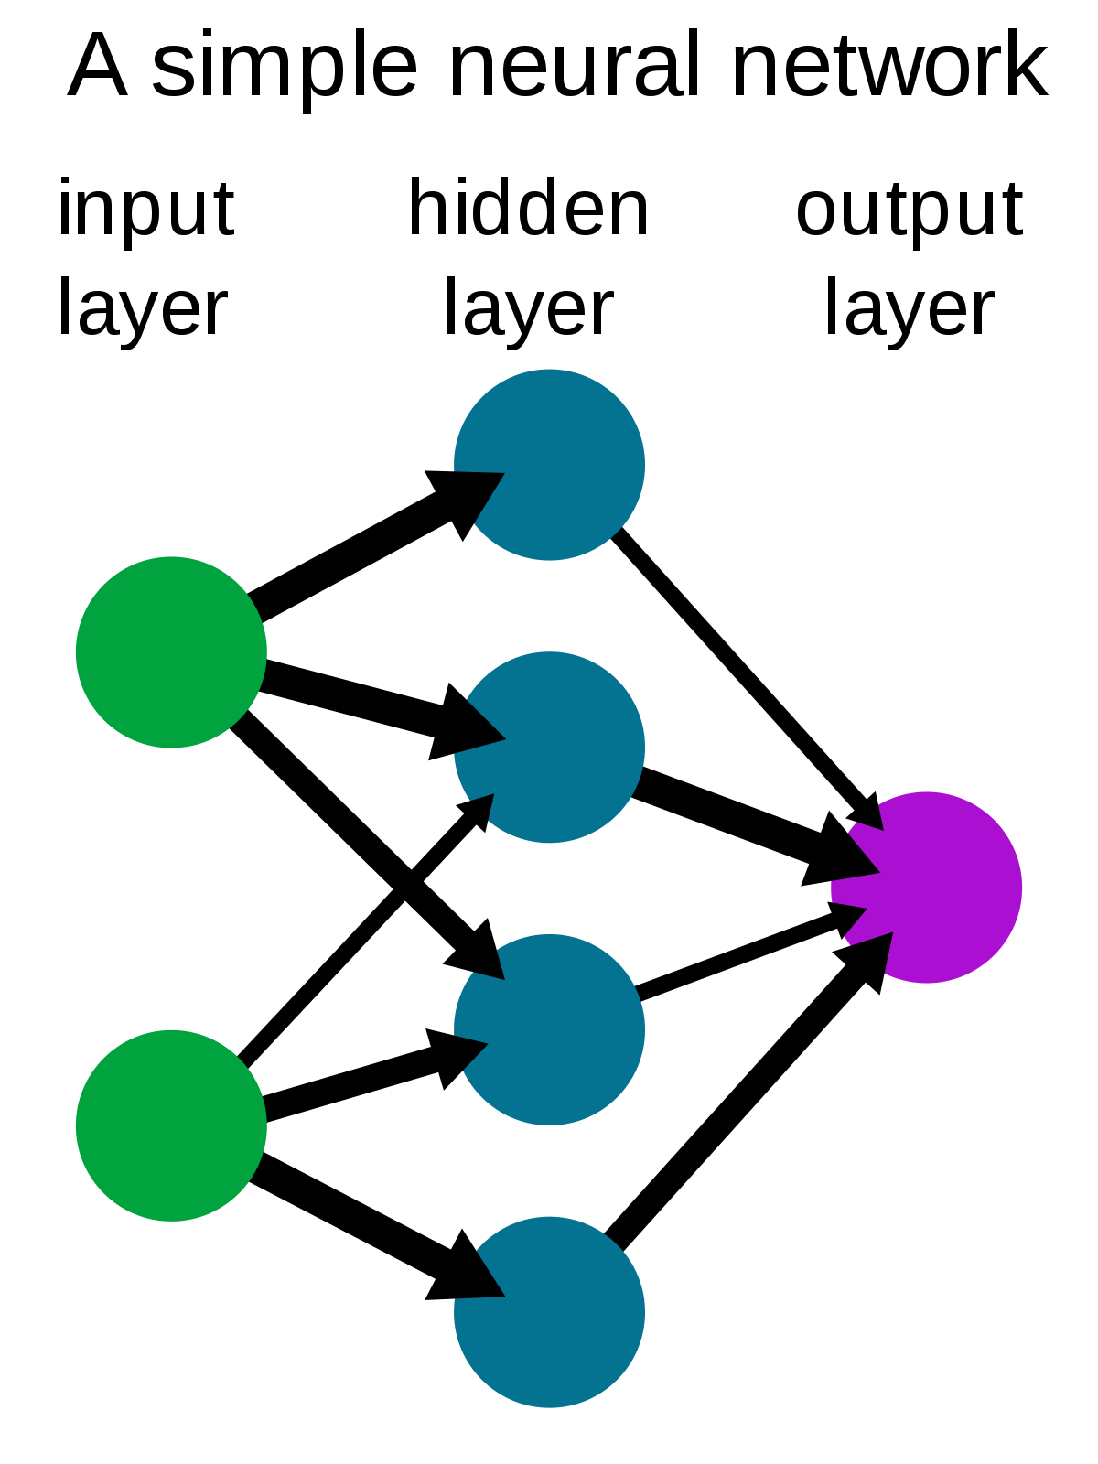

**Figure 1.1** WORKING OF SIMPLE NEURAL NETWORK

**Input layer:** Patterns are introduced to the neural network by the input layer that has one neuron for each component present in the input data

**Hidden layer:** The input layer communicates to one or more hidden layers present in the network and it is called ‘hidden’ only due to the fact that they do not constitute the input or output layer. It is in the hidden layers where all the processing actually happens through a system of connections characterized by weights and biases**.**The input is received, the neuroncalculates a weighted sum adding also the bias and according to the result and a pre-set **activation function**(most common one is sigmoid, σ, even though it almost not used anymore and there are better ones like ReLU), it decides whether it should be ‘fired’ or activated. Afterwards, the neuron transmit the information downstream to other connected neurons in a process called ‘forward passes’*.*

**Neurons:** The neuron’s goal is to **adjust the weights**based on lots of examples of inputs and outputs. The neuron decides:

* which features are important and positive
* which features are not important
* which features are important and negative

Some of the major activities carried out by neurons are:

* It takes the inputs and multiplies them by their weights,
* then it sums them up,
* After that it applies the activation function to the sum.

**Activation Function:** Activation function decides, whether a neuron should be activated or not by calculating weighted sum and further adding bias with it. The purpose of the activation function is to **introduce non-linearity** into the output of a neuron. A neural network without an activation function is essentially just a linear regression model. The activation function does the non-linear transformation to the input making it capable to learn and perform more complex tasks.

**Output layer:** At the end of this process, the last hidden layer is linked to the output layer which has one neuron for each possible desired output.

**1.2.1 TYPES OF NEURAL NETWORKS**

There are 7types of neural networks that can be used.

* The first is a multilayer perceptron which has three or more layers and uses a nonlinear activation function.
* The second is the convolutional neural network that uses a variation of the multilayer perceptron.
* The third is the recursive neural network that uses weights to make structured predictions.
* The fourth is a recurrent neural network that makes connections between the neurons in a directed cycle. The long short-term memory neural network uses the recurrent neural network architecture and does not use activation function.
* The final two are sequence to sequence modules which uses two recurrent networks and shallow neural networks which produces a vector space from an amount of text. These neural networks are applications of the basic neural network demonstrated below.

This project uses the LSTM along with MFCC feature extraction method to recognise Spoken Digits and CNN model to recognise handwritten digits.

**1.3 LONG SHORT TERM MEMORY NETWORK**

Long Short-Term Memory (LSTM) networks are a type of recurrent neural network capable of learning order dependence in sequence prediction problems. This is a behaviour required in complex problem domains like machine translation, speech recognition, and more. LSTMs are a complex area of deep learning. LSTM was proposed in 1997 by [**Sepp Hochreiter**](https://en.wikipedia.org/wiki/Sepp_Hochreiter) and [**Jürgen Schmidhuber**](https://en.wikipedia.org/wiki/J%C3%BCrgen_Schmidhuber).By introducing Constant Error Carousel (CEC) units, LSTM deals with the exploding and vanishing gradient problems. The initial version of LSTM block included cells, input and output gates. LSTMs have an edge over conventional feed-forward neural networks and RNN in many ways. This is because of their property of selectively remembering patterns for long durations of time.

Recurrent Neural Networks work just fine when we are dealing with short-term dependencies. The RNN need not remember what was said before, or what the meaning was. The reason behind this is the problem of **Vanishing Gradient**. We know that for a conventional feed-forward neural network, the weight updating that is applied on a particular layer is a multiple of the learning rate, the error term from the previous layer and the input to that layer. Thus, the error term for a particular layer is somewhere a product of all previous layers’ errors. When dealing with activation functions like the sigmoid function, the small values of its derivatives (occurring in the error function) gets multiplied multiple times as we move towards the starting layers. As a result of this, the gradient almost vanishes as we move towards the starting layers, and it becomes difficult to train these layers.

LSTMs on the other hand, make small modifications to the information by multiplications and additions. With LSTMs, the information flows through a mechanism known as cell states. This way, LSTMs can selectively remember or forget things. The information at a particular cell state has three different dependencies.

These dependencies can be generalized to any problem as:

1. The previous cell state (i.e. the information that was present in the memory after the previous time step)
2. The previous hidden state (i.e. this is the same as the output of the previous cell)
3. The input at the current time step (i.e. the new information that is being fed in at that moment)

All recurrent neural networks have the form of a chain of repeating modules of neural network. In standard RNNs, this repeating module will have a very simple structure, such as a single tanh layer.

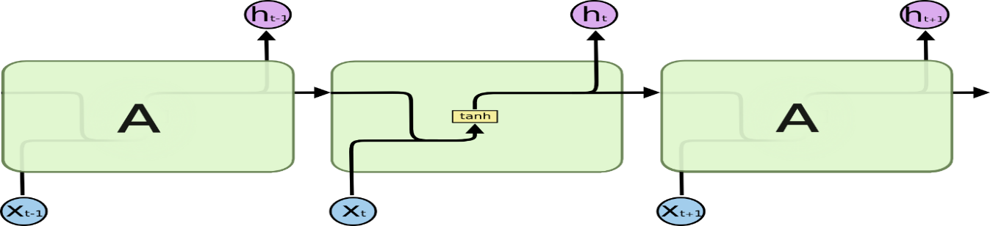

**Figure 1.2 The repeating module in a standard RNN contains a single layer.**

LSTMs also have this chain like structure, but the repeating module has a different structure. Instead of having a single neural network layer, there are four, interacting in a very special way.

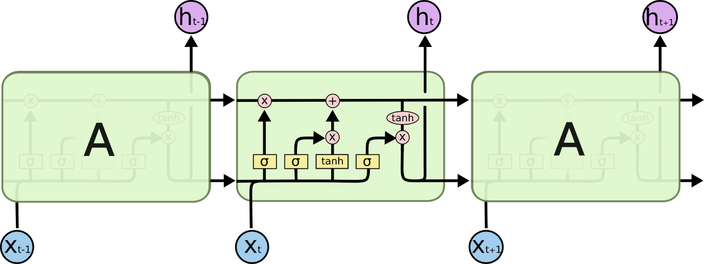

**Figure 1.3 The repeating module in an LSTM contains four interacting layers.**

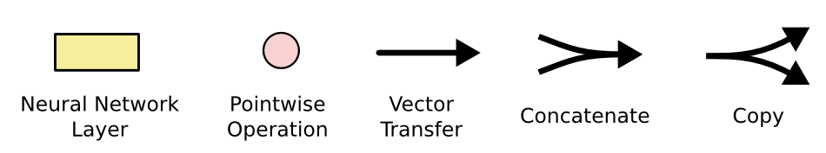

**Figure 1.4 Notations of LSTM network**

## **CORE IDEA BEHIND LSTMS**

The key to LSTMs is the cell state, the horizontal line running through the top of the diagram.

The cell state is kind of like a conveyor belt. It runs straight down the entire chain, with only some minor linear interactions. It’s very easy for information to just flow along it unchanged.

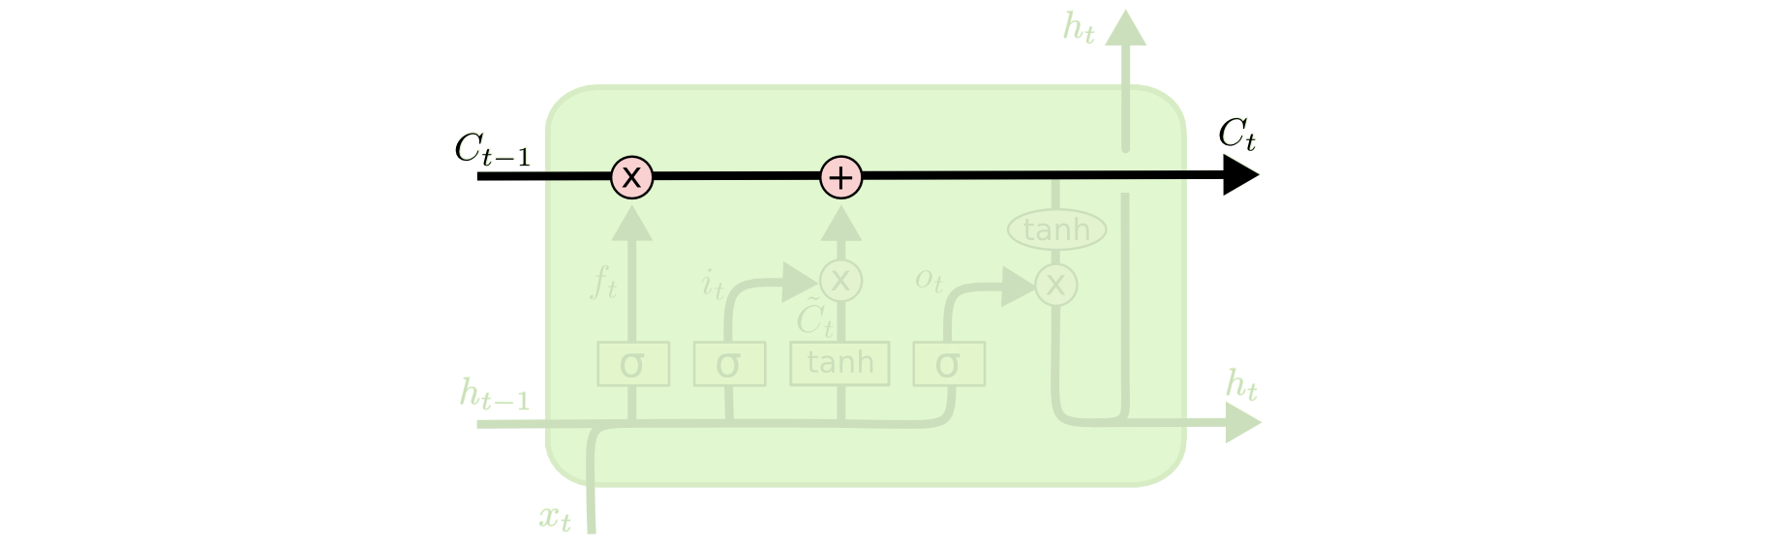

**Figure 1.5 Primary LSTM layer**

The LSTM does have the ability to remove or add information to the cell state, carefully regulated by structures called gates.

Gates are a way to optionally let information through. They are composed out of a sigmoid neural net layer and a pointwise multiplication operation.



**Figure 1.6 Sigmoid layer**

The sigmoid layer outputs numbers between zero and one, describing how much of each component should be let through. A value of zero means “let nothing through,” while a value of one means “let everything through!”

An LSTM has three of these gates, to protect and control the cell state.

**APPLICATIONS OF LSTM:**

* [Robot control](https://en.wikipedia.org/wiki/Robot_control)
* [Time series prediction](https://en.wikipedia.org/wiki/Time_series_prediction)
* [Speech recognition](https://en.wikipedia.org/wiki/Speech_recognition)
* Rhythm learning
* Music composition
* Grammar learning
* [Handwriting recognition](https://en.wikipedia.org/wiki/Handwriting_recognition)
* Human action recognition
* [Sign Language Translation](https://en.wikipedia.org/wiki/Sign_language)
* Protein Homology Detection
* Predicting subcellular localization of proteins
  1. **CONVOLUTIONAL NEURAL NETWORK**

A **Convolutional Neural Network (ConvNet/CNN)** is a Deep Learning algorithm which can take in an input image, assign importance (learnable weights and biases) to various aspects/objects in the image and be able to differentiate one from the other. The pre-processing required in a ConvNet is much lower as compared to other classification algorithms. While in primitive methods filters are hand-engineered, with enough training, ConvNets have the ability to learn these filters/characteristics. The architecture of a ConvNet is analogous to that of the connectivity pattern of Neurons in the Human Brain and was inspired by the organization of the Visual Cortex. Individual neurons respond to stimuli only in a restricted region of the visual field known as the Receptive Field. A collection of such fields overlap to cover the entire visual area.

In the context of a convolutional neural network, a convolution is a linear operation that involves the multiplication of a set of weights with the input, much like a traditional neural network. Given that the technique was designed for two-dimensional input, the multiplication is performed between an array of input data and a two-dimensional array of weights, called a filter or a kernel.

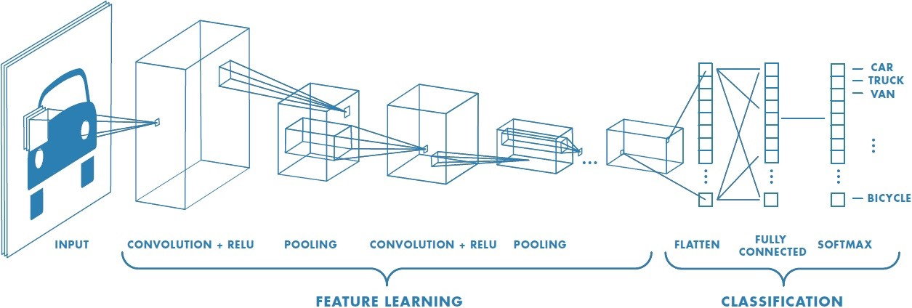

**Figure 1.7: Neural network with many convolutional layers**

**CONVOLUTION LAYER**

Convolution is the first layer to extract features from an input image. Convolution preserves the relationship between pixels by learning image features using small squares of input data. It is a mathematical operation that takes two inputs such as image matrix and a filter or kernel.

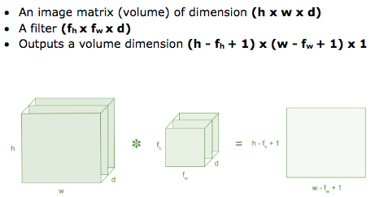

**Figure 1.8: Image matrix multiplies kernel or filter matrix**

Consider a 5 x 5 whose image pixel values are 0, 1 and filter matrix 3 x 3 as shown in below

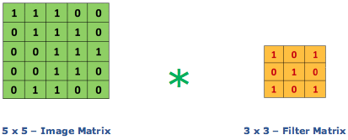

**Figure 1.9: Image matrix multiplies kernel or filter matrix**

Then the convolution of 5 x 5 image matrix multiplies with 3 x 3 filter matrix which is called **“Feature Map”** as output shown in below



**Figure 1.10: 3 x 3 Output matrix**

Convolution of an image with different filters can perform operations such as edge detection, blur and sharpen by applying filters. The below example shows various convolution image after applying different types of filters (Kernels).

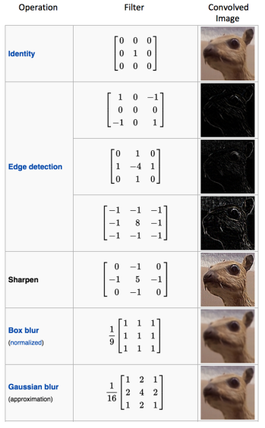

**Figure 1.11: Some common filters**

**PADDING**

Sometimes filter does not fit perfectly fit the input image. We have two options:

* Pad the picture with zeros (zero-padding) so that it fits
* Drop the part of the image where the filter did not fit. This is called valid padding which keeps only valid part of the image.

**NON LINEARITY (RELU)**

ReLU stands for Rectified Linear Unit for a non-linear operation. The output is ***ƒ(x) = max (0, x).***

Why ReLU is important: ReLU’s purpose is to introduce non-linearity in our ConvNet. Since, the real world data would want our ConvNet to learn would be non-negative linear values.

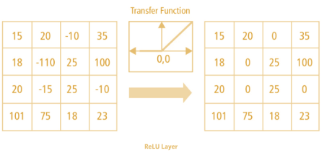

**Figure 1.12: ReLU operation**

There are other nonlinear functions such as tanh or sigmoid that can also be used instead of ReLU. Most of the data scientists use ReLU since performance wise ReLU is better than the other two.

**POOLING LAYER**

Pooling layers section would reduce the number of parameters when the images are too large. Spatial pooling also called subsampling or down sampling which reduces the dimensionality of each map but retains important information. Spatial pooling can be of different types:

* Max Pooling
* Average Pooling
* Sum Pooling

Max pooling takes the largest element from the rectified feature map. Taking the largest element could also take the average pooling. Sum of all elements in the feature map call as sum pooling.

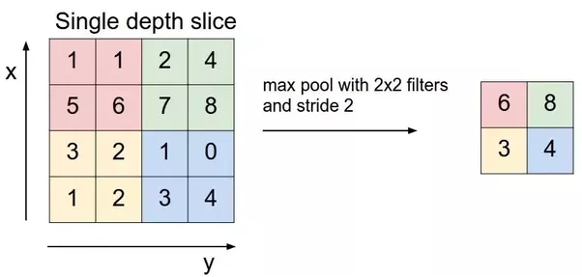

**Figure 1.13: Max Pooling**

**FULLY CONNECTED LAYER**

The layer we call as FC layer, we flattened our matrix into vector and feed it into a fully connected layer like a neural network.

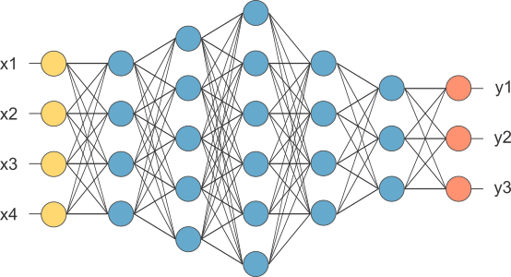

**Figure 1.14: After pooling layer, flattened as FC layer**

In the above diagram, the feature map matrix will be converted as vector (x1, x2, x3…). With the fully connected layers, we combined these features together to create a model. Finally, we have an activation function such as softmax or sigmoid to classify the outputs as cat, dog, car, truck etc.

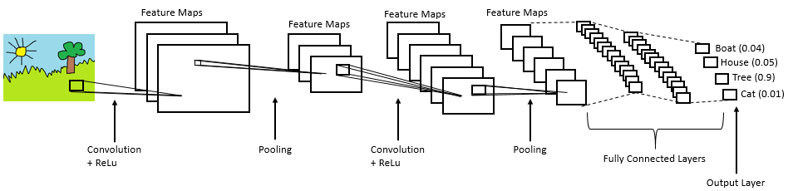

**Figure 1.15: Complete CNN architecture**

**APPLICATIONS OF CNN:**

• Image recognition

• Video analysis

• Natural language processing

• Anomaly Detection

• Drug discovery

• Health risk assessment and biomarkers of aging discovery

**1.5 OBJECTIVE**

The primary objective of this project is to develop an multifaceted digit recognition application that comprises individual applications to recognise numerical digits from 0-9 using speech and handwritten techniques with the help of Long Short Term Memory Network and Convolutional Neural Network respectively. To evaluate the accuracy of both the network models for all the digits from 0-9.

* 1. **EXISTING SYSTEM**

The current speech recognition techniques uses the wavelet scattering method to extract features from the audio signal. Using Artificial Neural Network (ANN), digits are recognised with varying frequencies from 80-90% but not with 100% accuracy.

There are several downsides associated with wavelet scattering and CNN such as:

* for fine analysis, it becomes computationally intensive
* Wavelet scattering takes some energy to invest in wavelets to become able to choose the proper ones for a specific purpose, and to implement it correctly.
* High computational cost.
* Good GPU to train (for complex tasks).
* They need a lot of training data.
  1. **PROPOSED SYSTEM**
* To design and develop a multifaceted digit recognition application that can recognise both spoken digits and handwritten digits.
* To develop two different neural networks to recognise spoken digits and handwritten digits.
* To evaluate the parameters to be used to train the developed model.
* To evaluate the developed model performance in terms of the classification accuracy.

**1.7.1 ADVANTAGES**

* This is a novel method to integrate both recognition of spoken and handwritten digits in a single application.
* Two different neural networks in a single application.
* Higher accuracy than usual traditional methods.
* Add on is an webcam integrated script to recognise handwritten digits through webcam
* MFCC is simple compared to wavelet scattering and Linear Predictive Coding.
* CNN used achieves higher accuracy with less dataset which means the network is well built.

**CHAPTER 2**

**LITERATURE SURVEY**

# “Vocal digit recognition using Artificial Neural Network”, by D. B. Hanchate, Mohini Nalawade, Manoj Pawar, Vijay Pophale, Prabhat Kumar Maurya

# Machine recognition of spoken numbers has attracted a lot of attention because several numerical information such as account number, credit card number, telephone number can be fed to the machine conveniently in the voice mode. A number recognition system based on Artificial Neural Network is described here. The base system employs mel frequency cepstral coefficients. In this paper a simple and effective time alignment is used for spoken digit recognition systems. While high power computers are available today, time alignment algorithms, such as dynamic time warping algorithm need relatively high CPU time, which should be reserved for other complicated tasks. During recognition process, digitized speech was cleaned of noise, then the signal was pre-emphasized and it was windowed and blocked by Hamming window, the time alignment algorithm is used to compensate for the differences in the utterance length. Frames features are extracted using MFCC coefficients to reduce the amount of the information in the input signal. Finally, the neural network classifies the unknown digit.

1. “**Automatic Spoken Digit Recognition Using Artificial Neural Network”, by P. Sarma, S. Sarmah, M.P. Bhuyan, K. Hore, P.P. Das**

Speech Processing is a vast domain for research work where Speech Recognition is a small part of it. This research work is an attempt to recognize ten spoken English digits starting from zero to nine by using Artificial Neural Network. The system will be able to recognize digits spoken in English. Although the spoken language is English, the utterance may vary from speaker to speaker. We have built the system by training the voice samples of the people of the North-eastern region of India. After recognizing the utterance it will display the recognized digit as output. We have programmed and simulated the design in MATLAB. The design of our research is based on using the Linear Prediction Coefficient (LPC) and Principal Component Analysis (PCA) for signal analysis. We were able to get an overall accuracy of 82%.

1. **“Handwritten Digit Recognition using CNN”, by Vijayalaxmi R Rudraswamimath, Bhavanishankar K**

Digit Recognition is a noteworthy and important issue. As the manually written digits are not of a similar size, thickness, position and direction, in this manner, various difficulties must be considered to determine the issue of handwritten digit recognition. The uniqueness and assortment in the composition styles of various individuals additionally influence the example and presence of the digits. It is the strategy for perceiving and arranging transcribed digits. It has a wide range of applications, for example, programmed bank checks, postal locations and tax documents and so on. The aim of this project is to implement a classificatio n algorithm to recognize the handwritten digits. The after effects of probably the most broadly utilized Machine Learning Algorithms like SVM, KNN and RFC and with Deep Learning calculation like multilayer CNN utilizing Keras with Theano and Tensorflow. Utilizing these, the accuracy of 98.70% utilizing CNN (Keras + Theano) when contrasted with 97.91% utilizing SVM, 96.67% utilizing KNN, 96.89% utilizing RFC was obtained.

1. **“CNN-Based Recognition of Handwritten Digits in MNIST Database”, by Huimin Wu**

For humans, identifying numbers or items in a picture is extremely simple, but how do you train the machine to recognize these different things in images? Convolutional Neural Networks (CNN) can solve this problem. In this report, a convolutional neural network has been trained by identifying pictures in MNIST handwritten digital database to predict exactly what the numbers in the picture are. Obviously, human beings can perceive that there is a hierarchy or conceptual structure in the image, but the machine does not, for example the trained neural network is inconvenient to deal with special changes in a position of numbers in digital pictures. Exactly put, no matter what the environment of the image (image background) is, it is unchallenging for human beings to judge whether there is such a figure in the image and it is unnecessary to repeat the learning training.

**CHAPTER 3**

**SYSTEM REQUIRMENT**

**3.1 HARDWARE REQUIRMENT**

* **Processor :** minimum of i3-i5 processor
* **Hard disk :** minimum of 60GB
* **RAM :** 4GB of RAM
* **Keyboard :** 110 keys enhanced

**3.2 SOFTWARE REQUIRMENT**

* **Operating system :** OS - Windows 8,10/Linux/MacOS
* **IDE :** Spyder development Environment

through Anaconda

* **Prompt :** Anaconda Prompt

Spyder is a powerful scientific environment written in Python, for Python, and designed by and for scientists, engineers and data analysts. It offers a unique combination of the advanced editing, analysis, debugging, and profiling functionality of a comprehensive development tool with the data exploration, interactive execution, deep inspection, and beautiful visualization capabilities of a scientific package

Beyond its many built-in features, its abilities can be extended even further via its plugin system and API. Furthermore, Spyder can also be used as a PyQt5 extension library, allowing developers to build upon its functionality and embed its components, such as the interactive console, in their own PyQt software.

Spyder is an [open source](https://en.wikipedia.org/wiki/Open-source_software) cross-platform [integrated development environment](https://en.wikipedia.org/wiki/Integrated_development_environment) (IDE) for scientific programming in the [Python language](https://en.wikipedia.org/wiki/Python_(programming_language)). It is released under the [MIT license](https://en.wikipedia.org/wiki/MIT_license). Initially created and developed by Pierre Raybaut in 2009, since 2012 Spyder has been maintained and continuously improved by a team of scientific Python developers and the community.

**FEATURES OF SPYDER (ANACONDA)**

* An editor with [syntax highlighting](https://en.wikipedia.org/wiki/Syntax_highlighting), [introspection](https://en.wikipedia.org/wiki/Introspection_(computer_science)), [code completion](https://en.wikipedia.org/wiki/Code_completion).
* Support for multiple [IPython](https://en.wikipedia.org/wiki/IPython) [consoles](https://en.wikipedia.org/wiki/Command-line_interface).
* The ability to explore and edit [variables](https://en.wikipedia.org/wiki/Variable_(computer_science)) from a [GUI](https://en.wikipedia.org/wiki/Graphical_user_interface).
* A Help pane able to retrieve and render rich text [documentation](https://en.wikipedia.org/wiki/Application_programming_interface#Documentation) on functions, classes and methods automatically or on-demand.
* A [debugger](https://en.wikipedia.org/wiki/Debugger) linked to IPdb, for step-by-step execution.
* [Static code analysis](https://en.wikipedia.org/wiki/Static_program_analysis), powered by [Pylint](https://en.wikipedia.org/wiki/Pylint).
* A run-time [Profiler](https://en.wikipedia.org/wiki/Profiling_(computer_programming)), to benchmark code.
* Project support, allowing work on multiple development efforts simultaneously.
* A built-in [file explorer](https://en.wikipedia.org/wiki/File_manager), for interacting with the filesystem and managing projects.
* A "Find in Files" feature, allowing full [regular expression](https://en.wikipedia.org/wiki/Regular_expression) search over a specified scope.
* An online help browser, allowing users to search and view Python and package documentation inside the IDE.
* A [history log](https://en.wikipedia.org/wiki/Command_history), recording every user command entered in each console.
* An internal console, allowing for introspection and control over Spyder's own operation.

## **WRITING THE CODE:**

Writing code in Spyder becomes very easy with its multi-language code editor and a number of powerful tools. As mentioned earlier, the editor has features such as syntax highlighting, real-time analysis of code, style analysis, on-demand completion, etc. When you write your code, you will also notice that it gives a clear call stack for methods suggesting all the arguments that can be used along with that method.

Below is an example of a sample code in Spyder:

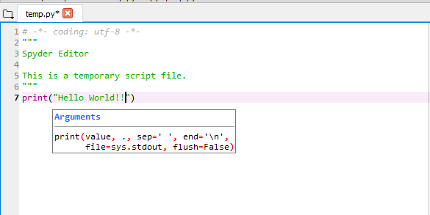

To run any file, you can select the Run option and click on run. Once executed, the output will be visible on the Console as shown in the image below:

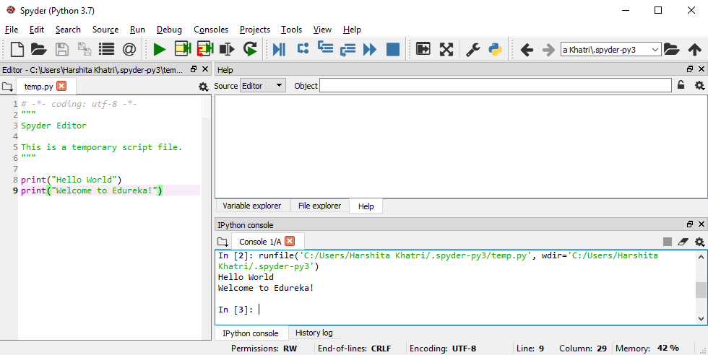

Spyder can be installed through Anaconda application. Anaconda is a [free and open-source](https://en.wikipedia.org/wiki/Free_and_open-source)distribution of the [Python](https://en.wikipedia.org/wiki/Python_(programming_language)) and [R](https://en.wikipedia.org/wiki/R_(programming_language)) programming languages for [scientific computing](https://en.wikipedia.org/wiki/Scientific_computing) ([data science](https://en.wikipedia.org/wiki/Data_science), [machine learning](https://en.wikipedia.org/wiki/Machine_learning) applications, large-scale data processing, [predictive analytics](https://en.wikipedia.org/wiki/Predictive_analytics), etc.), that aims to simplify [package management](https://en.wikipedia.org/wiki/Package_management) and deployment. Package versions are managed by the [package management system](https://en.wikipedia.org/wiki/Package_manager) [conda](https://en.wikipedia.org/wiki/Conda_(package_manager)). The Anaconda distribution includes data-science packages suitable for Windows, Linux, and MacOS.

The following applications are available by default in Navigator:

* [JupyterLab](https://en.wikipedia.org/wiki/Project_Jupyter#JupyterLab)
* [Jupyter Notebook](https://en.wikipedia.org/wiki/Project_Jupyter#Jupyter_Notebook)
* QtConsole
* [Spyder](https://en.wikipedia.org/wiki/Spyder_(software))
* [Glue](https://en.wikipedia.org/wiki/Glue_(software))
* [Orange](https://en.wikipedia.org/wiki/Orange_(software))
* [RStudio](https://en.wikipedia.org/wiki/RStudio)
* [Visual Studio Code](https://en.wikipedia.org/wiki/Visual_Studio_Code)

**ANACONDA PROMPT:**

Simple python scripts can be easily executed in anaconda prompt that comes with the Anaconda application. The prompt can be used to install python libraries and dependencies needed for certain programs like NumPy, tensor flow, Keras etc. Below is a snapshot of the Anaconda Prompt:

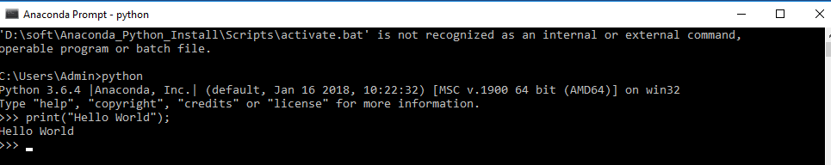

**3.3 CODING LANGAUGE USED:**

Python is an [interpreted](https://en.wikipedia.org/wiki/Interpreted_language), [high-level](https://en.wikipedia.org/wiki/High-level_programming_language), [general-purpose](https://en.wikipedia.org/wiki/General-purpose_programming_language) [programming language](https://en.wikipedia.org/wiki/Programming_language). Created by [Guido van Rossum](https://en.wikipedia.org/wiki/Guido_van_Rossum) and first released in 1991, Python's design philosophy emphasizes [code readability](https://en.wikipedia.org/wiki/Code_readability) with its notable use of [significant whitespace](https://en.wikipedia.org/wiki/Off-side_rule). Its language constructs and [object-oriented](https://en.wikipedia.org/wiki/Object-oriented_programming) approach aim to help programmers write clear, logical code for small and large-scale projects.

Python is a general-purpose interpreted, interactive, object-oriented, and high-level programming language. It was created by Guido van Rossum during 1985- 1990. Like Perl, Python source code is also available under the GNU General Public License (GPL).

Python is a MUST for students and working professionals to become a great Software Engineer especially when they are working in Web Development Domain. Below are some of the key advantages of learning Python:

* **Python is Interpreted** − Python is processed at runtime by the interpreter. You do not need to compile your program before executing it. This is similar to PERL and PHP.
* **Python is Interactive**− you can actually sit at a Python prompt and interact with the interpreter directly to write your programs.
* **Python is Object-Oriented** − Python supports Object-Oriented style or technique of programming that encapsulates code within objects.
* **Python is a Beginner's Language** − Python is a great language for the beginner-level programmers and supports the development of a wide range of applications from simple text processing to WWW browsers to games.

## **APPLICATIONS OF PYTHON**

As mentioned before, Python is one of the most widely used language over the web. I'm going to list few of them here:

* **Easy-to-learn** − Python has few keywords, simple structure, and a clearly defined syntax. This allows the student to pick up the language quickly.
* **Easy-to-read** − Python code is more clearly defined and visible to the eyes.
* **Easy-to-maintain** − Python's source code is fairly easy-to-maintain.
* **A broad standard library**− Python's bulk of the library is very portable and cross-platform compatible on UNIX, Windows, and Macintosh.
* **Interactive Mode** − Python has support for an interactive mode which allows interactive testing and debugging of snippets of code.
* **Portable** − Python can run on a wide variety of hardware platforms and has the same interface on all platforms.
* **Extendable** − One can add low-level modules to the Python interpreter. These modules enable programmers to add to or customize their tools to be more efficient.
* **Databases** − Python provides interfaces to all major commercial databases.
* **GUI Programming** − Python supports GUI applications that can be created and ported to many system calls, libraries and windows systems, such as Windows MFC, Macintosh, and the X Window system of Unix.
* **Scalable** − Python provides a better structure and support for large programs than shell scripting.

**CHAPTER 4**

**SYSTEM DESIGN**

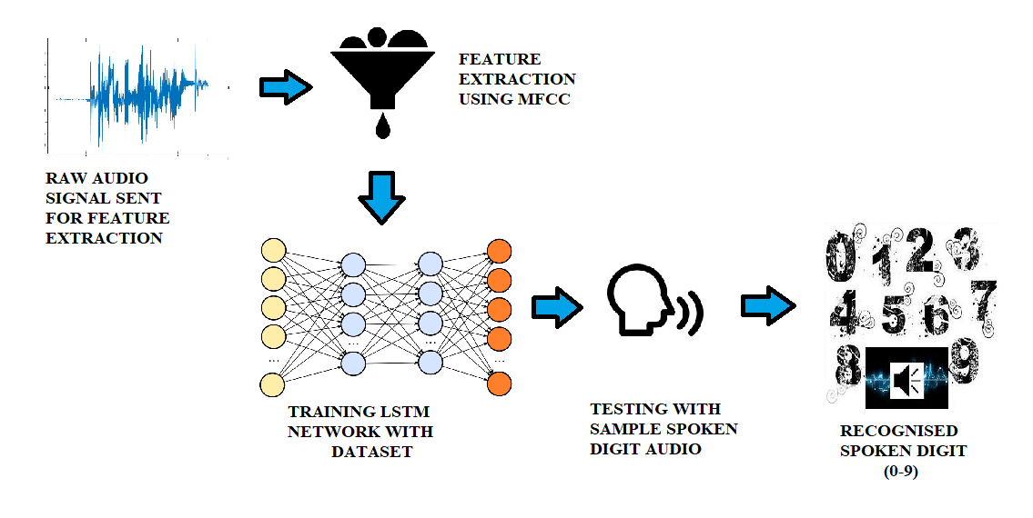**4.1 ARCHITECTURE DIAGRAM**

**FIGURE 4.1** **ARCHITECTURE DIAGRAM FOR SPOKEN DIGIT RECOGNITION**

**4.1.1 FLOW DIAGRAM FOR SPOKEN DIGIT RECOGNITION**

1

**Dataset from “free spoken digit database”**

**Mel frequency Cepstral function**

**Low Variance feature extraction**

**Feeding raw audio input signals**

**Train LSTM networks**

**Tune hyper parameters for neural network**

**Retrain LSTM network**

**Obtain accuracy and result**

Long-Short term memory network (LSTM)

**Send extracted features as input to LSTM**

2

3

4

5

6

7

8

9

Audio signals are usually long sequences of information that can be inefficient to directly feed as inputs to classification neural networks. There are various time-frequency representations to measure energy (or power) from a signal like Mel Frequency Cepstral Coefficients (MFCC), Fourier-based coefficients, wavelet scattering coefficients etc. This project uses MFCC to extract low variance features from the audio signals sent into the network. Once the audio signals from the dataset are pushed into the neural network to train, the first is to extract features i.e. identify the components of the audio signal that are good for identifying the linguistic content and discarding all the other stuff which carries information like background noise, emotion etc.

Once features are extracted using this technique for the audio signals, the extracted features are sent as inputs to the neural network built with LSTMs. The LSTM consists of 5 layers namely input sequence layer, an LSTM layer, fully connected layer, softmax layer and classification layer. There are various network as well as training parameters that can be tuned to achieve better results (accuracy) for this dataset. Number of hidden layers for LSTM is one of the key parameters to be tuned in the network. Learning rate, dropout rate, number of epochs, number of iterations are some other training parameters that can be tuned. Once the network is trained, it can be tested with some testing audio signals that read out digits from 0-9. Once the audio is pushed into the network, the network predicts the spoken digit with its confidence value.

* 1. 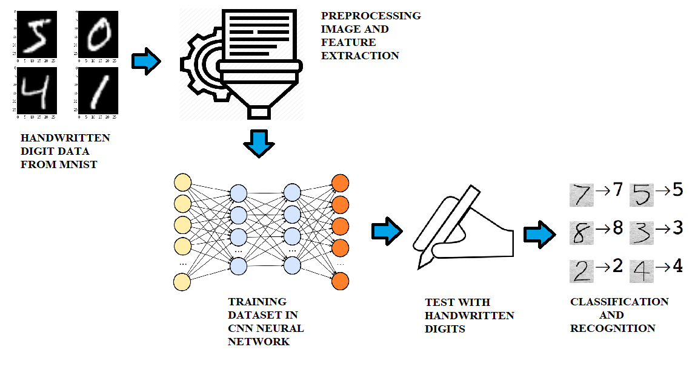**ARCHITECTURE DIAGRAM**

**FIGURE 4.2 ARCHITECTURE DIAGRAM FOR HANDWRITTEN DIGIT RECOGNITION**

**4.2.1 FLOW DIAGRAM FOR HANDWRITTEN DIGIT RECOGNITION**

1

**Dataset from “MNIST” database**

**Pre-processing images (reshaping, cross check)**

**Feature extraction**

**Feeding handwritten digit dataset**

**Input layers with weighted nodes**

**Hidden layers with arbitrary values. Training by dot product**

**Output layer with highest activation of digits**

**Obtain accuracy and result**

Conventional Neural network (CNN)

**Send extracted features as input to CNN**

2

3

4

5

6

7

8

9

CNN is primarily used in object recognition by taking images as input and then classifying them in a certain category. Handwritten digit recognition is one of that kind. We will be having a set of images which are handwritten digits with their labels from 0 to 9. First, the dataset is loaded from the Modified National Institute of Standards and Technology (MNIST) database. The dataset is called itself by using special import statements of Keras and Tensorflow. Tensorflow is a free and open-source software library for dataflow and differentiable programming across a range of tasks. It is a symbolic math library, and is also used for machine learning applications such as neural networks. Keras is an [open-source](https://en.wikipedia.org/wiki/Open-source_software) [neural-network](https://en.wikipedia.org/wiki/Artificial_neural_network) library written in [Python](https://en.wikipedia.org/wiki/Python_(programming_language)). It is capable of running on top of [Tensorflow](https://en.wikipedia.org/wiki/TensorFlow), [Microsoft Cognitive Toolkit](https://en.wikipedia.org/wiki/Microsoft_Cognitive_Toolkit), [R](https://en.wikipedia.org/wiki/R_(programming_language)), [Theano](https://en.wikipedia.org/wiki/Theano_(software)) or  [PlaidML](https://en.wikipedia.org/wiki/PlaidML), Designed to enable fast experimentation with [deep neural networks](https://en.wikipedia.org/wiki/Deep_learning), it focuses on being user-friendly, modular, and extensible.

Once the dataset is called, the network is built with 5 layers namely dense layer, Dropout layer, Flatten layer, convolutional layer, pooling layer, and NumPy. After building the network, it can be executed to train with the help of the dataset and the trained model is saved. The network can be tuned using dropout rate, epochs etc.

To test the network, handwritten digits are given as input through special Graphical User Interface (GUI), and the accuracy is displayed for the predicted digit. Test inputs can be given through GUI or through a webcam, thus testing the network and classifying digits from 0-9.

**CHAPTER 5**

**SYSTEM IMPLEMENTATION**

**5.1 MODULAR DESCRIPTION**

Numerical digits play a vital role in our daily life. Right from setting alarms to important bank transactions, digits are used everywhere. Mathematics begins with numerical digits 0-9 and mathematics lays the foundation to science and technology. Astronomical calculations, cell phones, telephone directory services, online shopping, etc. and many other fields use the applications of numerical digits. Speech and handwritten text recognition technologies are growing at a very rapid phase as there is a lot of demand for automation of technologies around us. Considering various applications that recognise spoken data and handwritten data individually, it is important for the need of a single application that can perform both with the highest accuracies. LSTM with MFCC and CNN are being deployed in this project to develop both the technologies.

The digit recognition application opens with a GUI that welcomes the user and holds three buttons each specifying to another application. The first button is the handwritten digit recognition. The second button is the spoken digit recognition. The third button is an add on, which can recognise written digits through a webcam.

**5.2 SPOKEN DIGIT RECOGNITION**

**5.2.1 DATASET COLLECTION**

The training and testing dataset was downloaded from “Free Spoken Digit Dataset‟ provided by https://github.com/Jakobovski/free-spoken-digit-dataset. This dataset consists of 1000 recordings from 2 speakers with 50 recordings for each of the digits from 0 to 9.

**5.2.2 FEATURE EXTRACTION**

Once the dataset is loaded into the script, it has to be sent for feature extraction. Firstly, the file format of all the audio in the dataset has to be converted to .wav format to execute the feature extraction algorithm. The librosa load function loads the default sampling rate of the audio signal (**22050 Hz) and file path of audio files. The feature extraction process using MFCC is a very tedious process but thanks to the librosa function in Spyder, it has become a one line code:**

mfcc_features = librosa.feature.mfcc (raw_w, sampling_rate)

The extracted features of the audio signal have to be similar in shape and size and hence they are checked for their shapes individually. To shape the features of equal size, 0’s are padded to them, thus making them similar to each other and can be readily sent into the network.

**5.2.3 BUILDING THE LSTM NETWORK**

Once the features are extracted using wavelet scattering framework, they are passed to a simple neural network built using a single layer of LSTM. This neural network consists of an input sequence layer, an LSTM layer, a fully connected layer, softmax layer and a classification layer. There are various network as well as training parameters that can be tuned to achieve better results (accuracy) for this dataset. Number of hidden layers for LSTM is one of the key parameters to be tuned in the network. Learning rate, dropout rate, number of epochs, number of iterations are some other training parameters that can be tuned.

Initial parameters are set as follow:

* lr = 0.001 (learning rate)
* iterations_train = 20 (number of iterations)
* bsize = 64 (batch size)
* audio_features = 20 (number of features)
* utterance_length = 35
* ndigits = 10 (number of digits 0-9)

Build the network with layers:

* + Network layers = Input Sequence Layer (input audio sequence length)
  + LSTM layer (number of hidden layers)
  + Fully Connected Layer (number of classes)
  + Softmax layer
  + Classification layer

The **Input Sequence** layer accepts the features that were extracted from the raw audio signals using MFCC along with utterance length as a parameter.

The LSTM layer takes the previous layers output as its input along with dropout rate (0.5) and 128*4 (512) units.

The fully connected, softmax and classification layer are supporting layers to the network specifying the activation function used (softmax) and optimizer (Adam) used. Once the network is built, it can be executed to train itself moving in iterations as specified in the initial parameters (iterations_train * epoch). The trained model is saved and can be loaded at any time to test on testing audio signals.

**5.2.4 TESTING AND CLASSIFICATION**

The trained model is now loaded and a testing audio in .wav format is sent into the network for prediction. At first, the features are extracted from the audio using MFCC method similar to the initial extraction procedure. The prediction_digit method is called to predict the digit spoken in the audio.

The digit is predicted along with specifying the confidence of the network in predicting the digit. With the GUI provided, we can play and hear the audio signal that is sent into the network. Another button specifies the predicted digit by the network.

**An important advantage is that all the actions performed by the buttons are read out by the script to the user which can help the visually impaired a lot to easily use it.**

We can even record our own voices and send it into the network to recognise the digit. Thus, spoken digits are recognised by Long Short Term Memory Network.

**5.3 HANDWRITTEN DIGIT RECOGNITION**

**5.3.1 DATASET COLLECTION**

The dataset is loaded from the Modified National Institute of Standards and Technology (MNIST) database. The dataset is called itself by using special import statements of Keras and Tensorflow. This dataset has a training set of 60,000 examples, and a test set of 10,000 examples. The samples are of numerical digits from 0-9.

**5.3.2 PREPROCESSING IMAGE**

The training images from the dataset have to be pre-processed before entering the CNN network. The following procedures are followed in pre-processing method:

* Loaded the data in (x_train, y_train), (x_test, y_test) and then reshape x_train and x_test because CNN accepts only 4-D vector.
* To convert into 4D vector declare reshape(60000,28,28,1) , where 60000 is the number of training images, 28 is the image size ( two times 28 since dimension is 28×28), and 1 is the number of channels, and similarly in reshape(10000,28,28,1) where 10000 is the number of that are in the test set.
* After this, we also convert our target values into binary class matrices, which means 2 will be converted to matrix form [0,0,1,0,0,0,0,0,0,0] as num_classes is set to 10 i.e. number of classes=10 for digits 0-9.

**5.3.3 BUILDING THE CNN NETWORK**

The model which will be used is imported and here it is Sequential model which is prebuilt in Keras. Along with model, we have to also import dense layer, which will be used to predict the labels, then the Dropout layer which reduces overfitting, and then Flatten, which will help to convert a 3-d Array to 1-d. Then finally we have imported convolutional layer, pooling layer, and NumPy.

The summary of the network is explained below:

* Initially the input shape is set to (28, 28, 1) and number of classes is 10 for digits 0-9.
* The first hidden layer is a convolutional layer called a Convolution2D. The layer has 32 feature maps, which with the size of 3×3 and a rectifier activation function. This is the input layer, expecting images with the structure outline above [pixels][width][height].
* Next we define a pooling layer that takes the max called MaxPooling2D. It is configured with a pool size of 2×2.
* The next layer is a regularization layer using dropout called Dropout. It is configured to randomly exclude 25% of neurons in the layer in order to reduce overfitting.
* Next is a layer that converts the 2D matrix data to a vector called Flatten. It allows the output to be processed by standard fully connected layers.
* Next a fully connected layer with 128 neurons and rectifier activation function.
* Finally, the output layer has 10 neurons for the 10 classes and a softmax activation function to output probability-like predictions for each class.

The trained model is saved and can be loaded at any time to test on testing handwritten digits.

**5.3.4** **TESTING AND CLASSIFICATION**

The trained model can be loaded now to recognise handwritten digits. With the GUI provided, we can write the digit using any input device and the written digit will be displayed on the screen. On clicking the Predict button, the digit will be predicted by the CNN network. The GUI even reads back the digit written on the screen after being predicted by the network. A clear button clears the screen and makes way for recognising a new digit. The GUI even reads back the accuracy of the digit predicted up to 3 points after decimal.

**5.3.5 TESTING THROUGH WEBCAM**

Another method developed to test the CNN network was to recognise the handwritten digit through a webcam. The GUI allows access to open the webcam and opens two individual screens, one that shows live output from webcam and the other screen to detect edges of the digit written. The first screen displays the predicted digit. Thus, handwritten digits are predicted with the help of Convolutional Neural Network.

**CHAPTER 6**

**CONCLUSION AND FUTURE ENHANCEMENT**

**6.1 CONCLUSION**

A novel method to design and develop a single application that in cooperates both recognition of spoken and handwritten digits was implemented. Two individual neural networks Long Short Term Memory and Convolutional Neural Networks were used to recognise spoken and handwritten digits respectively. The performance of each module shows how strongly the network was built and how efficiently the network was trained. The usage of LSTM along with MFCC feature extraction method is a completely new method to recognise speech. LSTM provides an accuracy of 100% in recognising all spoken digits from 0-9. CNN provides varying frequencies from 90-100% in recognising handwritten digits. Digit 9 is quite vulnerable to detect using CNN as it involves edges of several digits within it. This application can be used by visually impaired people to enter numerical data in other applications. It can also be used in banking services like PIN entry, detail filling, online shopping, detect car plate numbers through cameras etc.

**6.2 FUTURE ENHANCMENT**

Future works can include recognition of multiple spoken and handwritten digits. Using optimization techniques like Bayesian optimization can increase the efficiency of both the networks. Enabling database options to save the predicted digits can be implemented.

**APPENDIX I**

**SAMPLE CODING**

**APPLICATION GUI**

import sys

import os

import tkinter.font as Tkfont

import tkinter as tk

from tkinter import *

root=tk.Tk()

root.geometry('1200x700')

root['bg'] = '#477EE6'

helv36 = Tkfont.Font(family='Helvetica', size=13, weight='bold')

lbl = Label(root, text="DIGIT RECOGNITION", font=("Arial Bold", 55))

lbl['bg'] = '#9BFFFF'

lbl.grid(column=0, row=0, padx=10, pady=10)

lbl = Label(root, text="WELCOME TO DIGIT RECOGNITION APPLICATION. PLEASE SELECT AMONG SPOKEN, HANDWRITTEN AND WEBCAM DIGIT RECOGNITION MODULES!", font=("Arial Bold", 12))

lbl['bg'] = '#477EE6'

lbl.grid(column=0, row=20, padx=10, pady=10)

def cnncall():

os.system('guifinal.py')

B=Button(root,text="HANDWRITTEN DIGIT RECOGNITION",command= cnncall, bg='#9BFFFF', font=helv36)

B.config(height=5, width=60)

B.grid(column=0, row=1000, padx=10, pady=10)

def lstmcall():

os.system('sound1.py')

B1=Button(root,text="SPOKEN DIGIT RECOGNITION",command= lstmcall, bg='#9BFFFF', font=helv36)

B1.config(height=5, width=60)

B1.grid(column=0, row=1500, padx=50, pady=50)

def camcall():

os.system('cam.py')

B2=Button(root,text="WEBCAM DIGIT RECOGNITION",command= camcall, bg='#9BFFFF', font=helv36)

B2.config(height=5, width=60)

B2.grid(column=0, row=1600, padx=40, pady=40)

root.mainloop()

**SPOKEN DIGIT RECOGNITION**

import sounddevice as sd

from scipy.io.wavfile import write

import os

import random

import tflearn

import librosa

import numpy as np

import pyttsx3

import librosa.display

import matplotlib.pyplot as plt

import tkinter as tk

from winsound import *

from tkinter import *

# EXTRACT MFCC FEATURES

def extract_mfcc(file_path, utterance_length):

# Get raw .wav data and sampling rate from librosa's load function

raw_w, sampling_rate = librosa.load(file_path, mono=True)

# Obtain MFCC Features from raw data

mfcc_features = librosa.feature.mfcc(raw_w, sampling_rate)

if mfcc_features.shape[1] > utterance_length:

mfcc_features = mfcc_features[:, 0:utterance_length]

else:

mfcc_features = np.pad(mfcc_features, ((0, 0), (0, utterance_length - mfcc_features.shape[1])),

mode='constant', constant_values=0)

return mfcc_features

# MAIN

def main():

# Initial Parameters

lr = 0.001

iterations_train = 20

bsize = 64

audio_features = 20

utterance_length = 35

ndigits = 10

# Get training data

train_batch = get_mfcc_batch("C:\\Users\\Hari Bharath\\Documents\\projtest\\data\\recordings\\train\\", 256, utterance_length)

# # Build Model

sp_network = tflearn.input_data([None, audio_features, utterance_length])

sp_network = tflearn.lstm(sp_network, 128*4, dropout=0.5)

sp_network = tflearn.fully_connected(sp_network, ndigits, activation='softmax')

sp_network = tflearn.regression(sp_network, optimizer='adam', learning_rate=lr, loss='categorical_crossentropy')

sp_model = tflearn.DNN(sp_network, tensorboard_verbose=0)

# Train Model

while iterations_train > 0:

X_tr, y_tr = next(train_batch)

X_test, y_test = next(train_batch)

sp_model.fit(X_tr, y_tr, n_epoch=10, validation_set=(X_test, y_test), show_metric=True, batch_size=bsize)

iterations_train -=1

sp_model.save("C:\\Users\\Hari Bharath\\Documents\\projtest\\model\\speech_recognition_own")

# # Test Model

sp_model.load("C:\\Users\\Hari Bharath\\Documents\\projtest\\model\\speech_recognition_own")

mfcc_features = extract_mfcc("C:\\Users\\Hari Bharath\\Documents\\projtest\\data\\recordings\\test\\2_hari.wav", utterance_length)

mfcc_features = mfcc_features.reshape((1,mfcc_features.shape[0],mfcc_features.shape[1]))

prediction_digit = sp_model.predict(mfcc_features)

print(prediction_digit)

return 0

if __name__ == '__main__':

main()

**HANDWRITTEN DIGIT RECOGNITION**

**CNN MODEL**

import numpy as np

import cv2

import matplotlib.pyplot as plt

from keras.models import Sequential

from keras.layers.core import Dense, Dropout, Activation, Flatten

from keras.layers import Conv2D, MaxPool2D

from keras import optimizers

from keras.datasets import mnist

from keras.utils import to_categorical

import keras

# ### loading mist hand written dataset

(X_train, y_train), (X_test, y_test) = mnist.load_data()

print(X_train.shape, y_train.shape, X_test.shape, y_test.shape)

# ## Applying threshold for removing noise

_,X_train_th = cv2.threshold(X_train,127,255,cv2.THRESH_BINARY)

_,X_test_th = cv2.threshold(X_test,127,255,cv2.THRESH_BINARY)

# ### Reshaping

X_train = X_train_th.reshape(-1,28,28,1)

X_test = X_test_th.reshape(-1,28,28,1)

# ### Creating categorical output from 0 to 9

y_train = to_categorical(y_train, num_classes = 10)

y_test = to_categorical(y_test, num_classes = 10)

# ## cross checking shape of input and output

print(X_train.shape, y_train.shape)

print(X_test.shape, y_test.shape)

# # Creating CNN model

input_shape = (28,28,1)

number_of_classes = 10

model = Sequential()

model.add(Conv2D(32, kernel_size=(3, 3),activation='relu',input_shape=input_shape))

model.add(Conv2D(64, (3, 3), activation='relu'))

model.add(MaxPool2D(pool_size=(2, 2)))

model.add(Dropout(0.25))

model.add(Flatten())

model.add(Dense(128, activation='relu'))

model.add(Dropout(0.5))

model.add(Dense(number_of_classes, activation='softmax'))

model.compile(loss=keras.losses.categorical_crossentropy,

optimizer=keras.optimizers.Adadelta(),metrics=['accuracy'])

model.summary()

history = model.fit(X_train, y_train,epochs=5, shuffle=True,

batch_size = 200,validation_data= (X_test, y_test))

model.save('digit_recog_cnn.h5')

**APPENDIX II**

**SCREENSHOTS**

**1. APPLICATION HOME PAGE**

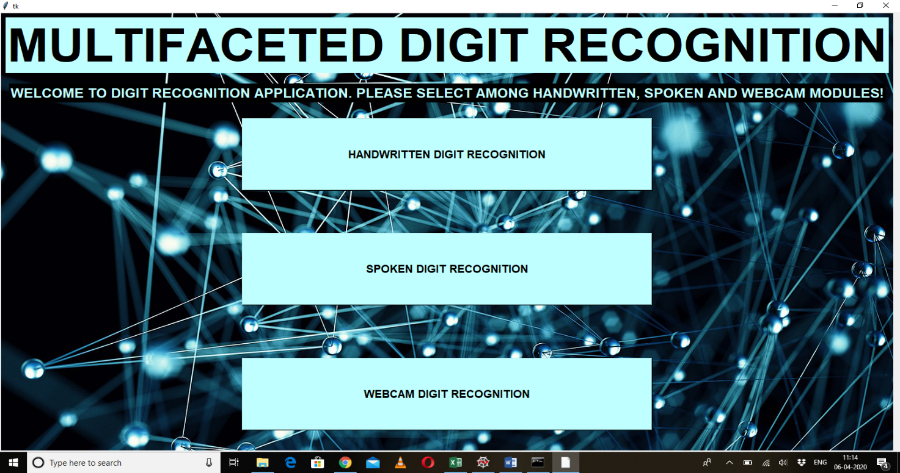

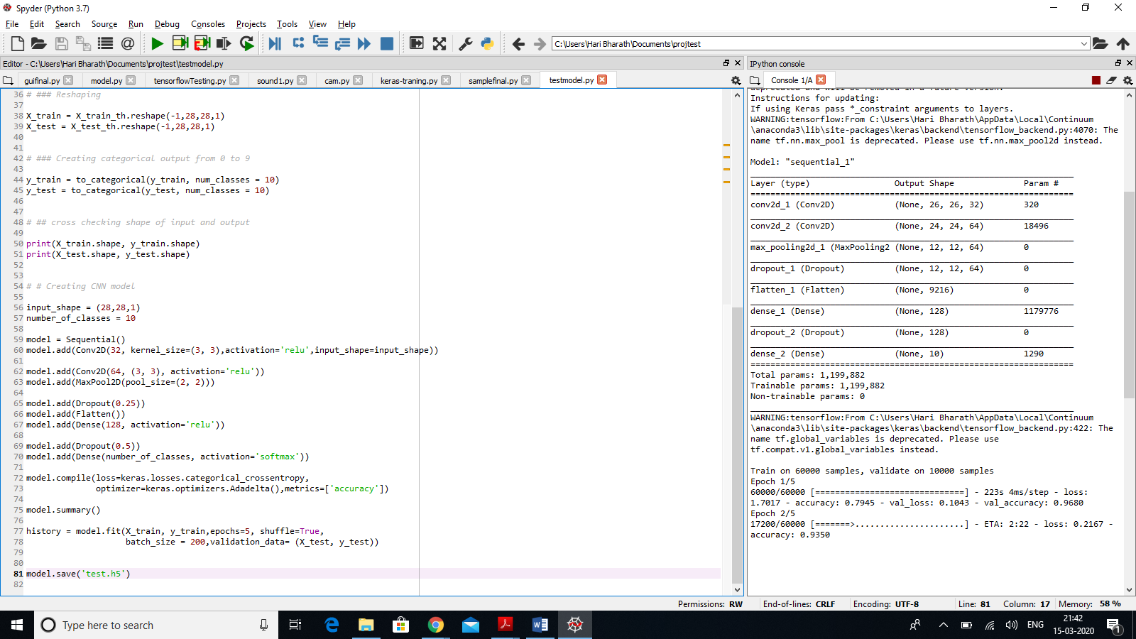**2. HANDWRITTEN DIGIT RECOGNITION- TRAINING CNN**

**3. HANDWRITTEN DIGIT RECOGNISED**

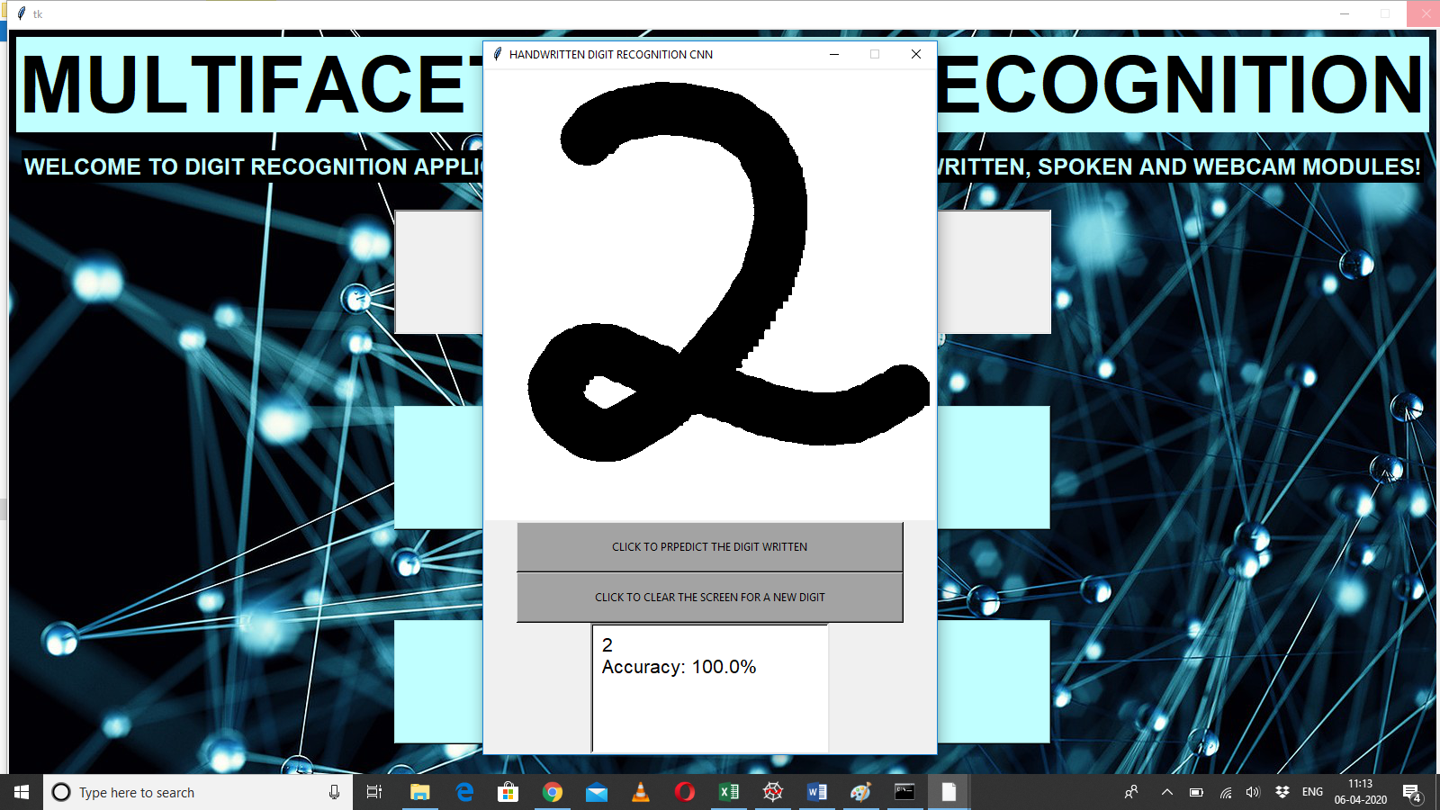

**4. SPOKEN DIGIT RECOGNITION-TRAINING LSTM**

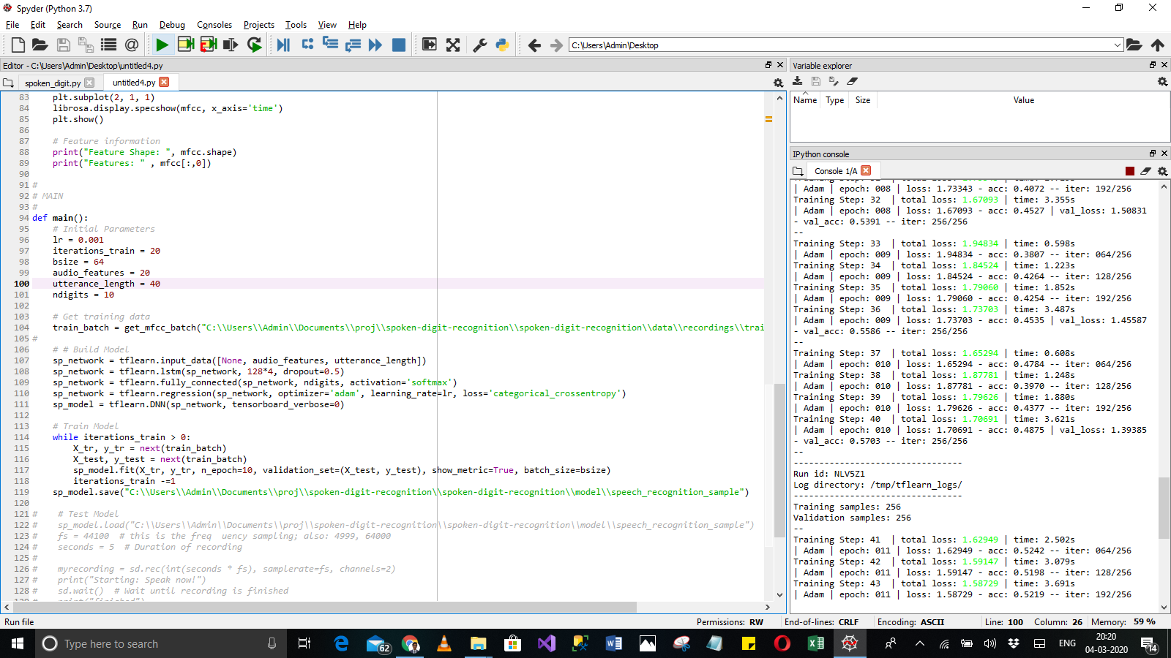

1. **SPOKEN DIGIT HOMEPAGE**

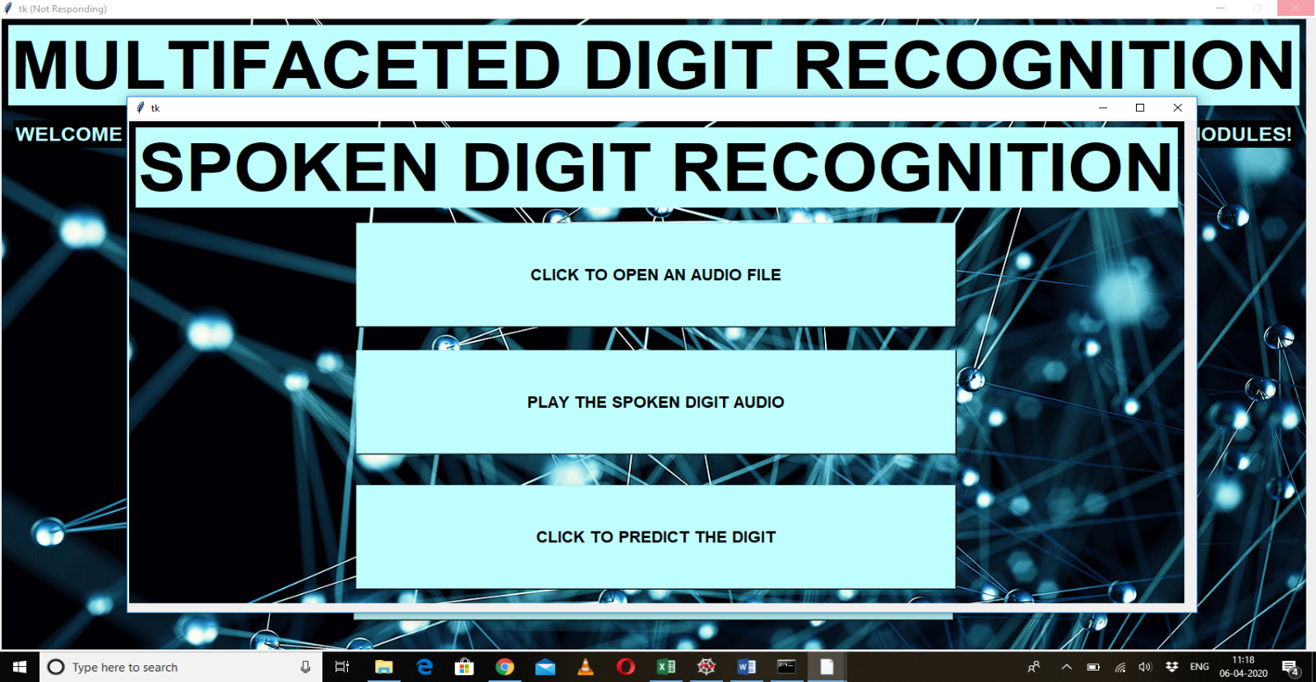

1. **OPENING AN AUDIO FILE**

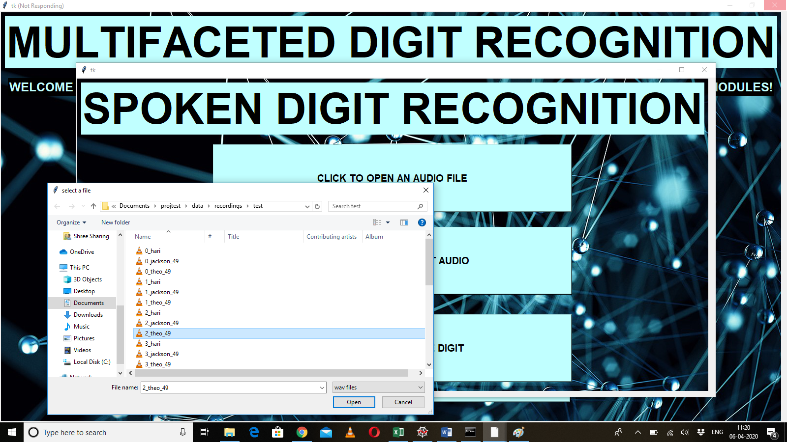

1. **PREDICTED SPOKEN DIGIT**

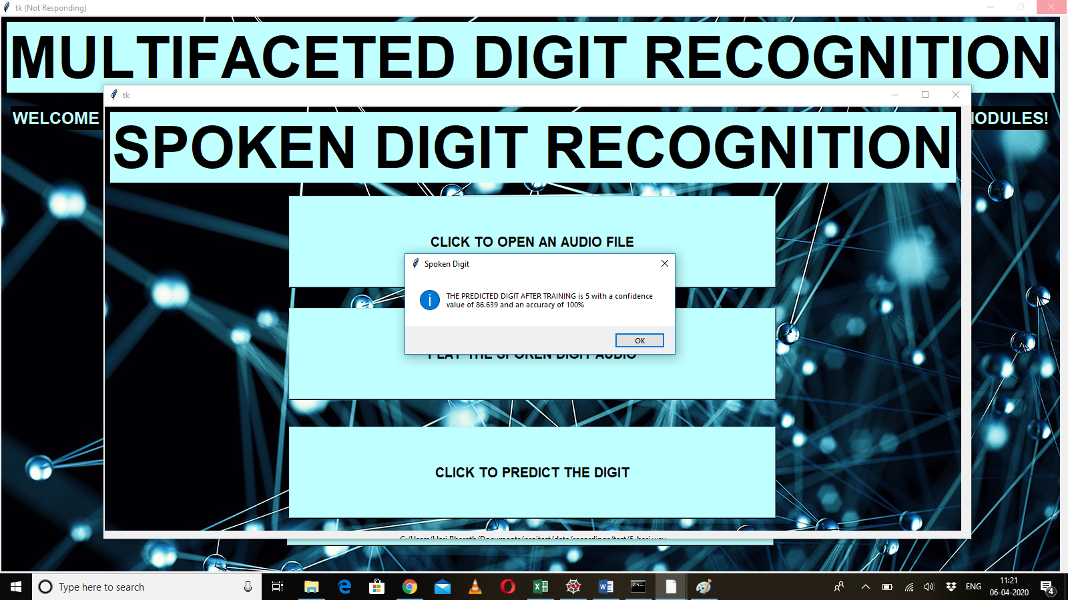

1. **WEBCAM DIGIT RECOGNITION**

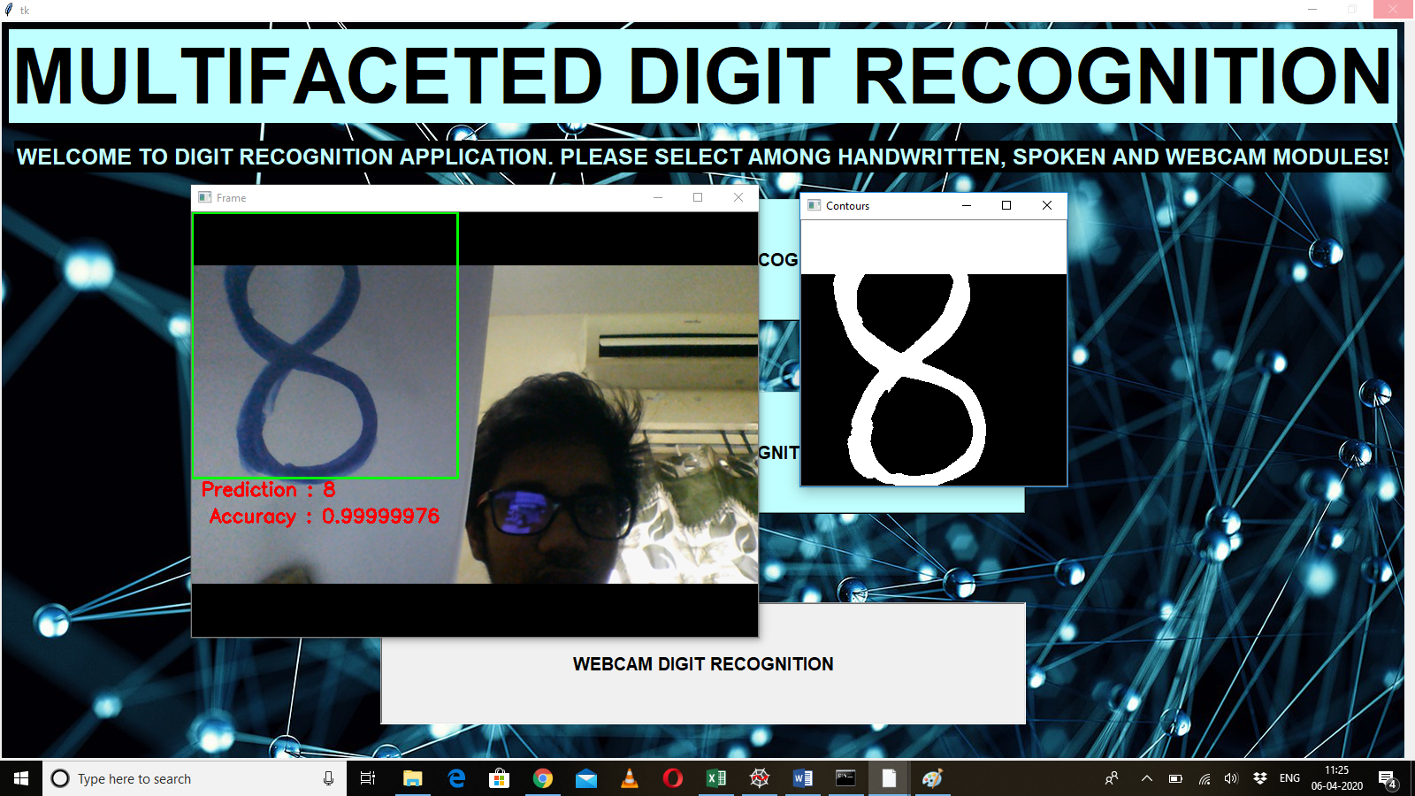

**REFERENCES**

[1] Wouter Gevaert, Georgi Tsenov, Valeri Mladenov, Senior Member, IEEE. ”Neural networks used for speech recognition”. Journal of automatic control, university of Belgrade, VOL.20:1-7,2010 ©

[2] Hochreiter, Sepp, and Jürgen Schmidhuber. "LSTM can solve hard long time lag problems." Advances in neural information processing systems. 1997.

[3] Bruna, Joan, and Stéphane Mallat. "Invariant scattering convolution networks." IEEE transactions on pattern analysis and machine intelligence 35.8 (2013): 1872-1886.

[4] Andén, Joakim, and Stéphane Mallat. "Deep scattering spectrum." IEEE Transactions on Signal Processing 62.16 (2014): 4114-4128.

[5] Tzanetakis, George, and Perry Cook. "Musical genre classification of audio signals." IEEE Transactions on speech and audio processing 10.5 (2002): 293-302.

[6] Andén, Joakim, and Stéphane Mallat. "Multiscale Scattering for Audio Classification." ISMIR. 2011.

[7] A free audio dataset of spoken digits. Think MNIST for audio. https://github.com/Jakobovski/free-spoken-digit-dataset.

[8] Hochreiter, Sepp, and Jürgen Schmidhuber. "LSTM can solve hard long time lag problems." Advances in neural information processing systems. 1997.

[9] Keras LSTM tutorial-How to easily build a powerful deep learning language model <https://adventuresinmachinelearning.com/keras-lstm-tutorial/>

[10]. M. Wu and Z. Zhang, Handwritten Digit Classification using the MNIST Dataset, 2010.

[11]. A. Dutta and A. Dutta, Handwritten digit recognition using deep learning, International Journal of Advanced Research in Computer Engineering & Technology (IJARCET), vol. 6, no. 7, July 2017.

[12]. Al Maadeed, Somaya, and Abdelaali Hassaine, Automatic prediction of age, gender, and nationality in offline handwriting. EURASIP Journal on Image and Video Processing, no. 1 2014.

[13]. Gaurav Jain, Jason Ko, Handwritten DigitsRecognition, Project Report, University of Toronto, 11/21/2008.

[14]. Hamid, Norhidayu Abdul, and NilamNur Amir Sjarif,Handwritten recognition using SVM, KNN and neural network, arXiv preprint arXiv:1702.00723 (2017).

[15]. R.G.Mihalyi, Handwritten digit classification using support vector machines, 2011.

[16]. D. B. Hanchate, Mohini Nalawade, Manoj Pawar, Vijay Pophale, Prabhat Kumar Maurya, “Vocal digit recognition using Artificial Neural Network”

[17] P. Sarma, S. Sarmah, M.P. Bhuyan, K. Hore, P.P. Das, “Automatic Spoken Digit Recognition Using Artificial Neural Network”.

[18] Huimin Wu, “CNN-Based Recognition of Handwritten Digits in MNIST Database”